C:\Users\MyPC\Pictures\RAGE ID\ID RAGE7.tif

C:\Users\MyPC\Pictures\RAGE ID\ID RAGE7.tif

**Danao City, Cebu, Philippines**

**C E R T I F I C A T I O N**

AUGUST 20, 2025

This is to certify that **Ranny Voughn L. Lopez**, **DW7RVL** is a regular member of **RADIO AMATEUR GROUP FOR EMERGENCY-7DC INC (RAGE -7DC)** base in Danao City, Cebu. He has participated with the group’s operation and other activities thru radio communication.

This certification is being issued for the renewal of his Amateur Radio Station License.

Very Truly Yours,

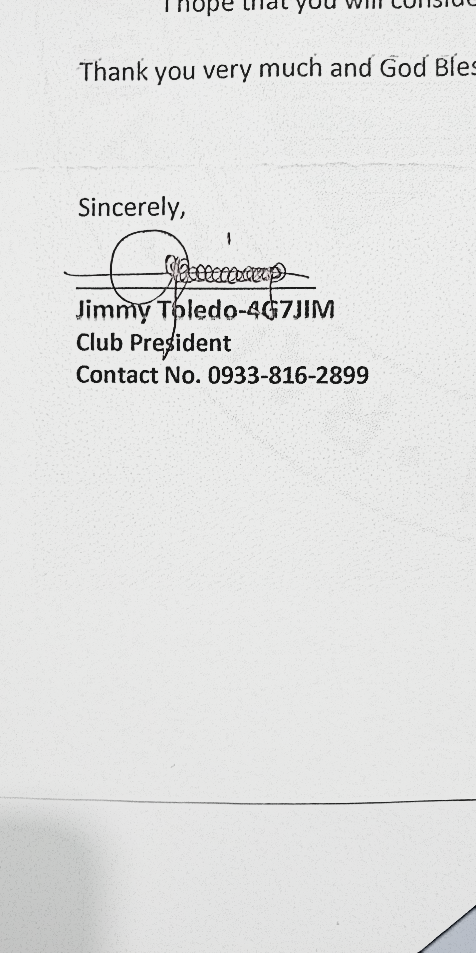

Control No. RAGE 7 DX-DAG-001-2025